18.14: a)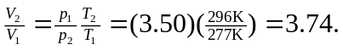 b) Lungs cannot withstand such a volume change; breathing is a good idea.

